**How to download the Jupyter Notebook ?**

**Description:** step by step tutorial from ANACONDA, Python to your Jupyter Notebook. **Time:** 5 mins.

**STEP1: Dwonload ANACONDA**

You can download from the links below:

<https://www.anaconda.com/download/success>

or <https://www.anaconda.com/download> or <https://www.anaconda.com/>

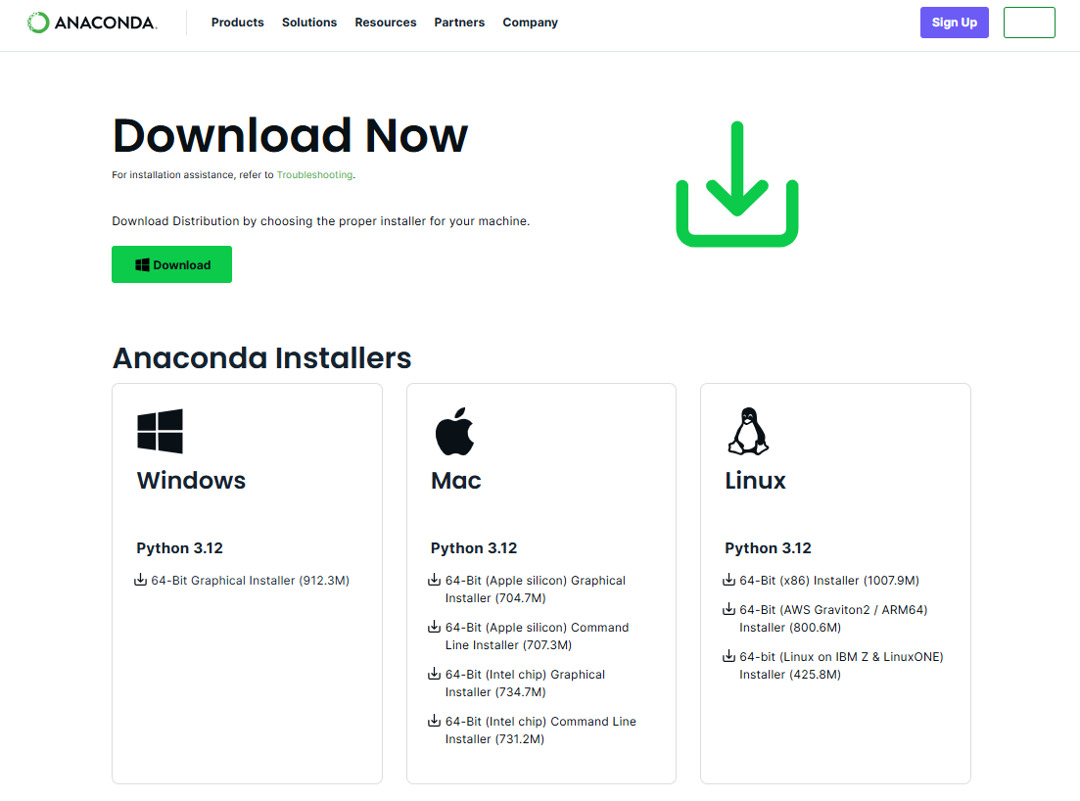

**STEP2: Download the Python**

You can download the version 3.12.4:

<https://www.python.org/downloads/>

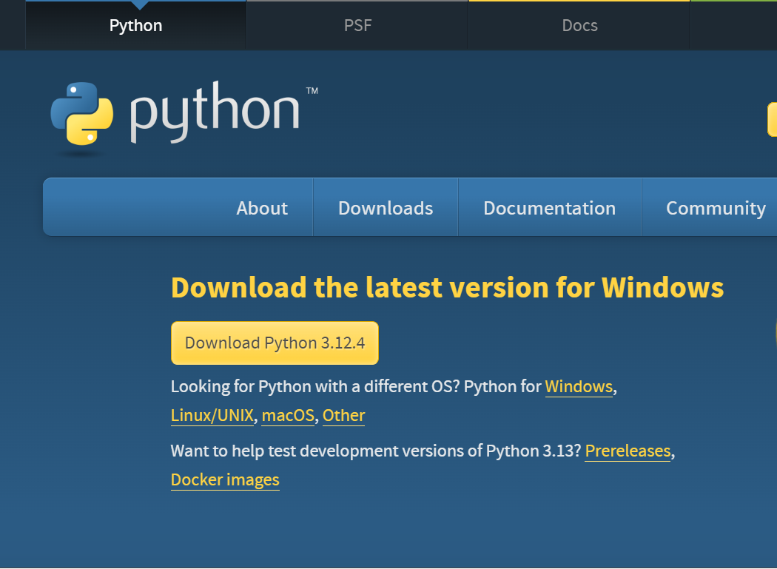

**STEP3: Launch Jupyter Notebook**

File Search ANACONDA.NAVIGATOR

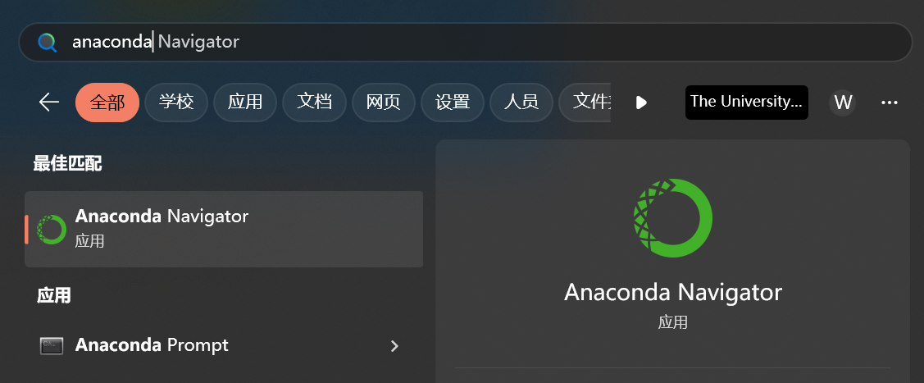

Click “**Launch**” to open your Jupyter Notebook

